Name____Dhana Gilling_____
Date___Feb. 08, 2011_______
TV Studio – Matching Activity

Please label each piece and what it does.

Video camera You record with it Hard Drive , that is in the
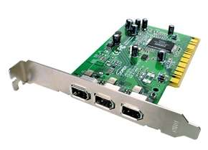
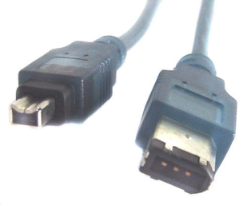
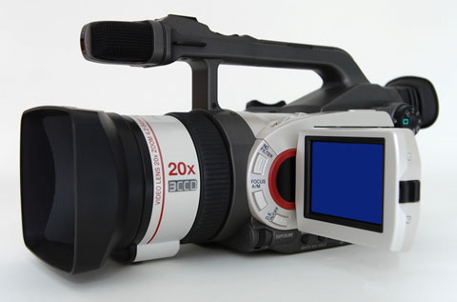

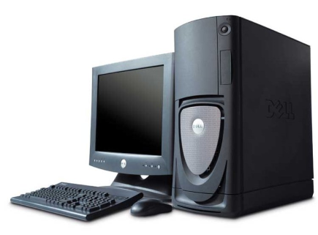
This is fire wire and it connects to the video camera then to the computer

This it the computer and monitor

